Answers to the written examination GEO4310 2010-11-26
These answers are examples; other formulations can also be correct for some questions.

Theory part

Q1:
- Return period – is the average recurrence interval between events equaling or exceeding (or, equal or below for low flows) a specific magnitude.

Recurrence interval = (n + 1) / m (Weibull formula)
n = number of years on record, m = the rank of the flood being considered.

- Expectation – the expected value of a random variable is defined as

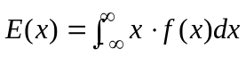 for continuous variables
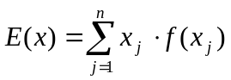 for discrete variable

- Variance – is a measure of dispersion. It is defined as the second moment about the mean:

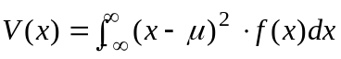 for continuous variable
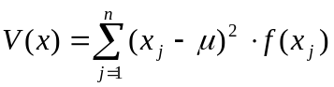 for discrete variable

- Covariance – If two variables X and Y are jointly distributed with density function f(x,y), the covariance of X and Y is defined as the (1, 1) central moment,

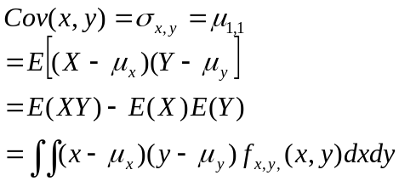
Sample estimate 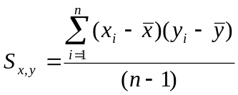
e) The mode is the value x having largest associated probability (i.e. the most often occurred value).
For discrete variable the mode is the value of x associated with
max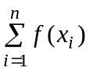

For a continuous variable the mode is the value of x satisfying
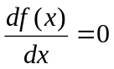 and 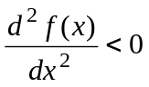
- The median is the value such that half of the values lie on either side of it.
Or the median is that value for which

P(XX_{median}) = P(XX_{median}) = 0.5

Q2
- The density function is the normal distribution and the probabilities are equal to the areas shown in the left gragh.
- For the cumulative probability distribution the probabilities can be shown on the y-axes, see right graph.
μ
Prob(a<x<b)
Prob(x>b)
a
Prob(a<x<b)
F(x)
a
b
b
Prob(x>b)
f(x)

Q3.
- Type I error: reject a true hypothesis, measured by significance level α.
Type II error: accept a false hypothesis, measured by β.
- As the value of α gets small, the value of β gets large. For the same a value, when the true population is close to the null hypothesized population the β is also getting large. This is because this is increasingly difficult to tell the difference between the two distributions. E.g.

β
β

Calculus part

Calculus Part (20p)

Q1
- expectation E(X)=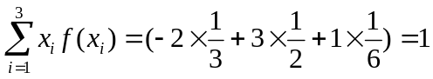
- variance Var(X)=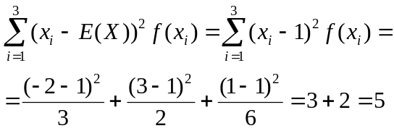
- mode is the value of X that gives the highest probability, i.e. 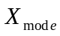=3
- median is that value for which

P(XX_{median}) = P(XX_{median}) = 0.5

If x is any value between 1 and 3, then P(Xx) = P(Xx) = 0.5. Thus, any number between 1 and 3 could represent the median. For example, we can choose the midpoint of the interval, i.e. X_{median} =2.

Q2
We have Q(t) ~ N(100, σ²)
P(Q>115) = 0.1 = P(Z>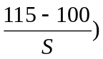
Then 1 - P(Z> = P(Z< = 0.9
From Table E.4 we get

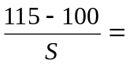1.28

Then S = 15/1.28 = 11.72

Q3
a) P(Q>q) = 0.75 → P(Q<q) = 0.25
P(ln(Q)<ln(q))=0.25
P(z<(ln(q)-5)/0.5) = 0.25
(ln(q)-5)/0.5 = -0.67
ln(q) = 4.665
q = exp(4.665) = 106 m3/s
b) P(Q<q) = 0.5 → P(Q>q) = 0.5
therefore q = 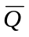 → ln(q) = 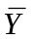 = 5 →q = exp(5) =148 m3/s

or P(Q<q) = 0.5 →P(z<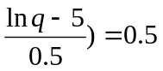→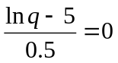
→ ln(q) = 5 →q = exp(5) =148 m3/s

c) P(Q<100) = P(ln(Q)<ln100) = P(z<(ln100-5)/0.5)
=P(z<-0.79) = 1-P(z<0.79) = 1-0.7852
=0.215
d) P(Q>q in one year) = 1/10 = 0.1
P(Q<q in one year) = 1-0.1 = 0.9
P(Q<q every year in 10 years) = 0.9^10 = 0.3487
P(Q>q at least one year in 10 years) = 1- P(Q<q every year in 10 years)
=1-0.3487 = 0.6513
Or Risk = 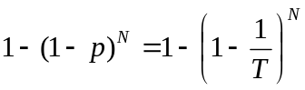
Here: T = 10, N = 10
Risk = at least 1 flood in 10 years = 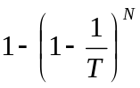= 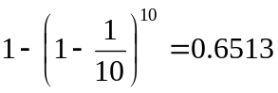
Q4
The Chi-square method:
Five classes have been selected, given explicitly in table below. The test statistics is
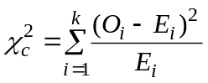
where k = 5 number of classes, Oi, Ei are observed and expected number in each class, respectively.
The values in the column for expected frequency have been determined as follows: (calculations are given explicitly for the first class only, i.e. the peak flows smaller or equal to 100m3/s).
f₁ = P(X≤100) = 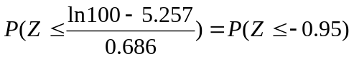=1-P(Z≤0.95) = 1-0.8289 = 0.1711
E₁ = f₁ ×35 = 5.99
Similarly, we can get
f2 = P(100<X≤150) = … … 0.1883
E2 = f2×35 = 6.59
f3 = P(150<X≤200) = … … 0.1645
E3 = f3×35 = 5.76
f4 = P(200<X≤300) = … … 0.2183
E4 = f4×35 = 7.64
f5 = P(X300) = … … 0.2578
E5 = f5×35 = 9.02
these values are given in column 4 and 5.

class | values | observed | expected | expected | (O-E)^2/E
 |  | number | frequency | number
 |  | Oi | fi | Ei
1 | ≤100 | 5 | 0.17 | 5.99 | 0.16
2 | 100~150 | 9 | 0.19 | 6.59 | 0.88
3 | 150~200 | 7 | 0.16 | 5.76 | 0.27
4 | 200~300 | 6 | 0.22 | 7.64 | 0.35
5 | ≥300 | 8 | 0.26 | 9.02 | 0.12
Total |  | 35 | 1.00 | 35.00 | 1.78

Ho rejects if 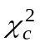>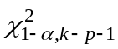
α = 0.05 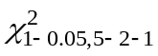=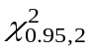= 5.99 > 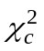=1.78 not reject

Therefore, no reason to say the data is not normally distributed.

